**TASK 2: Automating CI/CD Pipeline with Jenkins**

NAME: **SIVASAKTHI V**

ROLL NO: **22CSR197**

**STEP-1:Installation of Docker**

Install the Docker using the following commands:

•

1. sudo apt install docker.io
2. docker –version
3. sudo systemctl start docker
4. sudo systemctl enable docker
5. sudo systemctl status docker

**STEP-2:Fork a Github Repository**

Fork a copy of a GitHub repository, which will create a clone of that repository in your own

account.

**STEP-3:Change the username and image name**

In the deploy.sh file, update your Docker Hub username, personal access token (PAT), and

change the image name to the one you created in Docker.

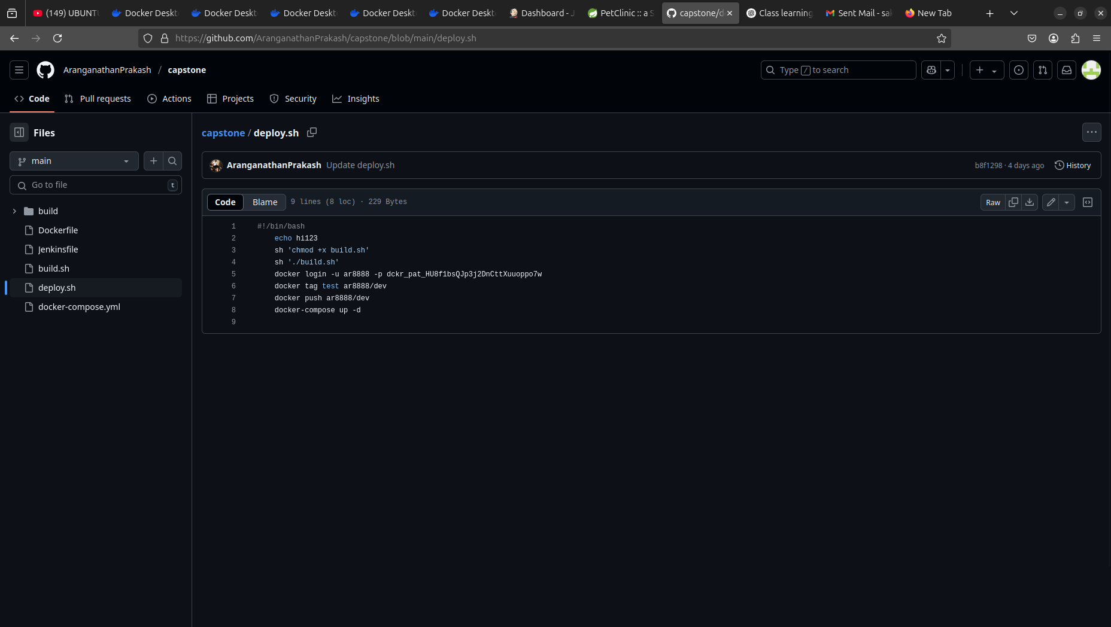

**STEP-4:Create a Pipeline Job in the Jenkins**

* In Jenkins, create a job using a pipeline.
* In the 'Definition' section, choose 'Pipeline script from SCM'.
* Under SCM, select 'Git', then paste the GitHub repository link in the 'Repository URL' field, which contains the script files for your job.
* Change the branch to match the one you're using in Git, and verify the filename.
* Finally, click 'OK' to proceed.

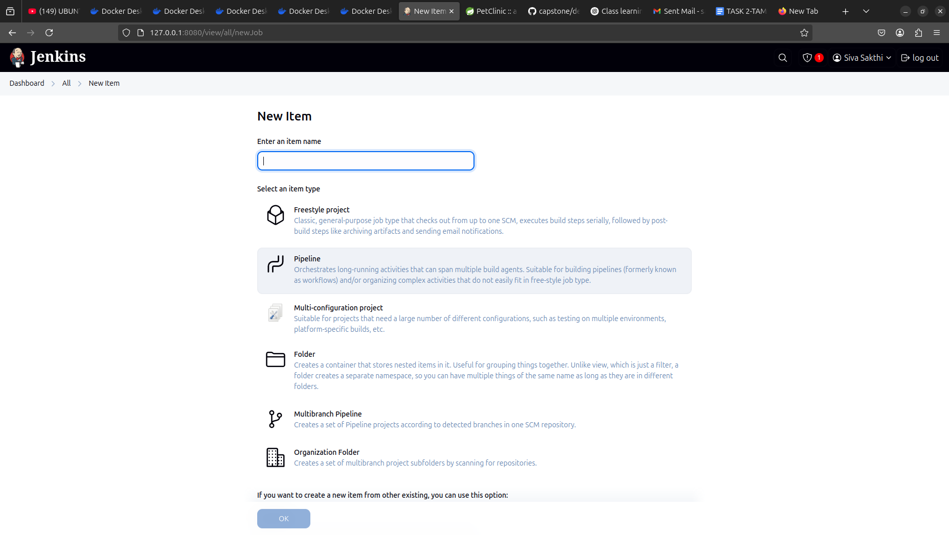

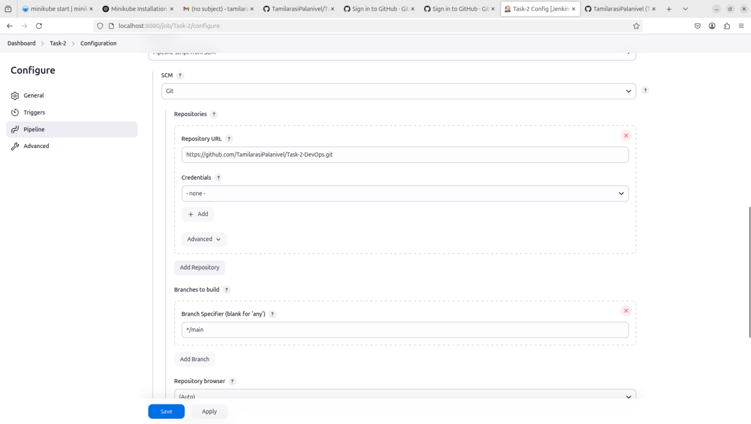

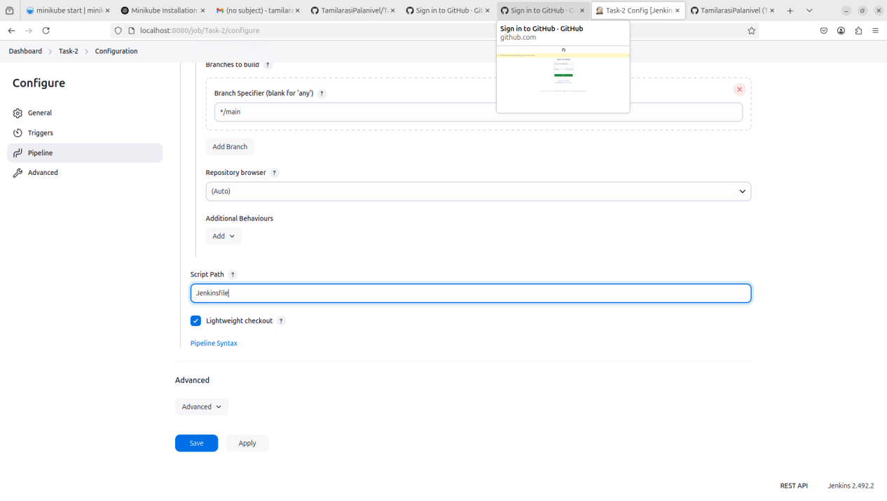

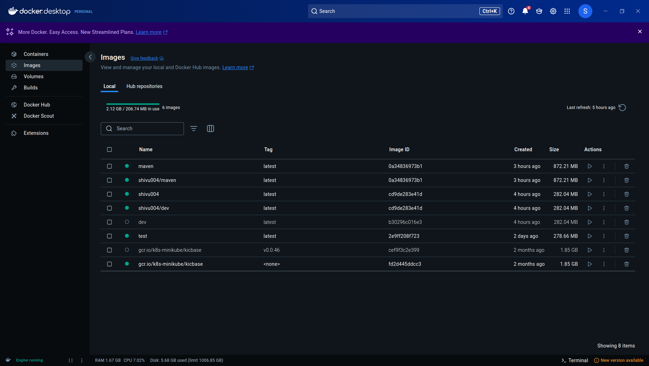

**STEP-5: BUILD NOW**

